Molly McGrath Tierney
Director

Talmadge Branch Building
1910 N. Broadway
Baltimore, Maryland
21213

Director’s Office:
443-378-4600

General Information:
1-800-332-6347


Stephanie Rawlings-Blake
Mayor

Commission Members

Mary J. Demory, Chair

Richard P. Barth
Pamela Bohrer Brown
Jacquelyn Duval-Harvey
Camron Ellerbee
M.Thomas Graham
Ernestine F. Jones
Ruth W. Mayden
Sam Macer
Anna R. McPhatter
David H. Thompson, Jr.

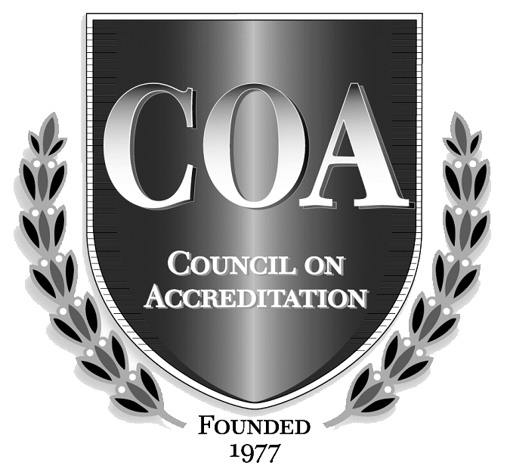

An Equal Opportunity Employer

Follow us at
http://twitter.com/BCDSSDirector



INVITATION FOR BID (IFB)

HOME HEALTH AND LEAD PAINT INSPECTIONS
PRE-BID CONFERENCE/TRANSCRIPT – BCDSS/AFS-12-033-S
AMENDMENT #2
June 8, 2012

Prospective Bidders:

This amendment is being issued to amend certain information in the above named IFB. All information contained herein is binding on all Bidders who respond to this IFB. The changes are listed below; new language has been double underlined and marked in bold (i.e., word), and language that has been deleted has been marked with a strikeout (i.e. word).

INVITATION FOR BIDS (IFB) – SECTION III. SPECIFICATIONS - Page 20

Old Language:
3.1 Background

BCDSS is the largest of Maryland’s twenty-four (24) local public Social Service agencies. BCDSS operates under the direction of the Department. Among its responsibilities is the safety and well being of approximately 3,700 abused and neglected children who are in State foster care.

New Language:
3.1 Background

BCDSS is the largest of Maryland’s twenty-four (24) local public Social Service agencies. BCDSS operates under the direction of the Department. Among its responsibilities is the safety and well being of approximately 3,400 abused and neglected children who are in State foster care.

Should you require clarification of the information provided in this Amendment,
please contact me via email at ggrant@dhr.state.md.us or by telephone at (443) 378-4783.

Date Issued: June 8, 2012

By:
Garcenia Grant
Procurement Officer

